**Lab Tutorial 3: OpenSim Scaling and Inverse Kinematics (IK)**

Download the *KinematicsLabData.zip* file from Canvas and unzip into your Documents folder or some place on the local hard drive. Within this folder you will see several motion capture (.c3d) files, a Jupyter notebook called *RotateMarkerData.ipynb*, and some pdf’s describing the data within this folder. If you want to know more about the complete set up of these gait lab experiments, the *Competition Data Description-4.pdf* file describes all of the data that was collected and other information about the lab, such as force plate orientations.

# Task 1. Prepare motion capture data and export .trc file.

As in the first tutorial, we will use *Mokka* to visualize our mocap data.

[Open up Mokka and drag in the *jw_staticfor.c3d* file into the main Mokka window]

This is a static, standing trial, which includes anatomical markers as well as technical, tracking markers. If you want to know what each of these markers are and where they are placed, there is a description of them in the *Marker Set Description.pdf* file. The marker labels in this file need to match the marker labels in the OpenSim model. If they don’t, you can either rename the markers in Mokka before you export them, or you can change the OpenSim model to match. Also, note that the global coordinate system of these data are typical for a motion capture lab, where the z-axis is vertical. These marker data ideally should be rotated to match the OpenSim coordinate system, where the y-axis is vertical. The Jupyter notebook, *RotateMarkerData.ipynb,* will open up a .trc file and rotate the marker data 90 deg about the x-axis, then re-export the data.

To export marker data as a TRC file from Mokka, select *File > Export > Motion Analysis Corp.*

*> TRC file*.

# Task 2. Add existing markerset to OpenSim model.

We will use the standard *Gait_2354_Simbody* model for this lab, which has 23 degrees of freedom and 54 muscle-tendon actuators. The model is located in the Gait2354_Simbody folder in the root directory of OpenSim (usually in the C:/ drive).

[Open up OpenSim and Select File > Open Model and select the *Gait2354_Simbody.osim*

model]

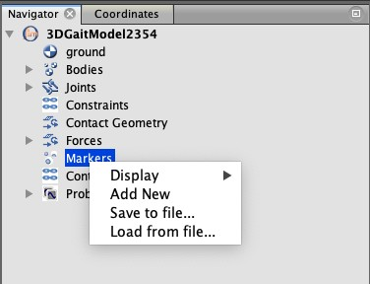When you expand the model in the Navigator menu, you can right click on the Markers and then select *Load from File*. Now you can browse to the unzipped lab data folder and select the GrandKneeMarkerSet.xml file.

This will load up a set of markers, which should (hopefully!) have the same marker names as those in the trc file that you just exported. You can double check the label names to be sure. It is important to appreciate in this step that the position of the pink, model markers should match as closely as possible the position of the real markers that you place on the participant. It can even be helpful to have a photograph of the participant with the markers attached to double check that everything looks in order. If you want to change the position of a marker, you can double click it to make it active, then click and drag it to a new position.

You can also type in the exact coordinates of the marker in the bottom left hand Properties

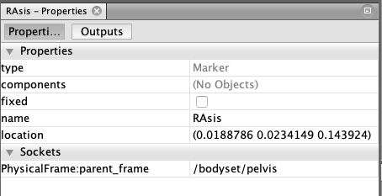box. Note the units here are metres, and the marker location is with respect to the parent body, so it also helps here to know the body local coordinate frame.

# Task 3. Scaling our generic model.

Now we are going to tell OpenSim how we want to scale the current model to match some new experimental markers. We will essentially generate a series of scale factors, which will be applied to each of the bodies in the .osim model. We could, for example, choose height as a scale factor and then apply uniform scaling to all body segments to match the participant height. This would assume that all of the body segments scale uniformly, which might be a poor assumption. Therefore, we typically select anatomical landmarks to provide some scaling dimensions for each body.

[from the OpenSim menu, select Tools > Scale Model]

This brings up the scale model menu, which has 3 main tabs at the top. There are 3 boxes in the first tab, which enable Subject Data to be input, and input .trc files for scaling the model and adjusting model markers. We typically have a static trial, which has both anatomical AND technical, tracking markers in the same file.

[Select the Scale Model button and then select the static trc file that you exported from Mokka in Task 1]

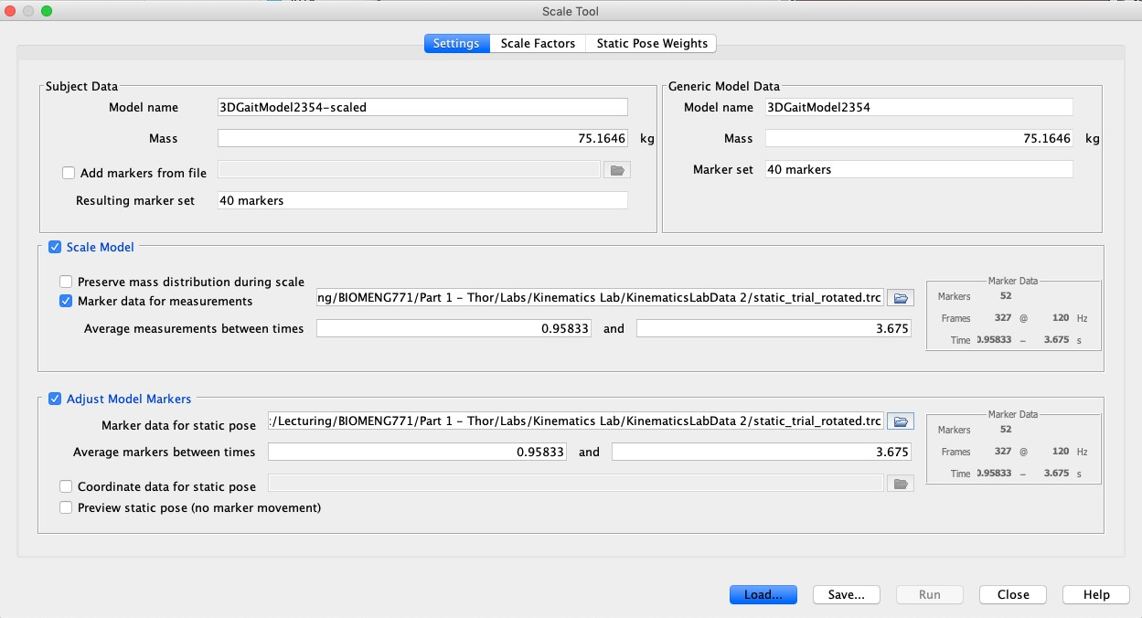[Select the same static trc file in the Adjust Model Markers section]

After you have selected the .trc file, you will see some information on the right hand side of the file, indicating the number of markers in the file, the total number of frames, as well as the capture frequency.

[Select the Scale Factors tab]

In this menu we will create various scale factors using the marker trajectories in the static standing trial to scale our model. You will initially see that each of the bodies in the model have Measurements ‘*Unassigned’* and the *Applied Scale Factors* are set to 1.0.

[Select the Edit Measurement Set button on the top right]

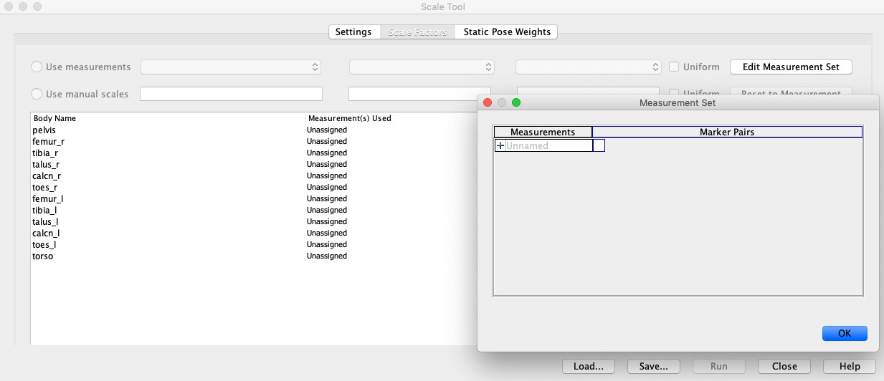

In here we will describe marker pairs, which will be used to scale the various bodies. As an example, we will scale the pelvis body using the two markers placed on the front of the pelvis. These anatomical landmarks are the left and right Anterior Superior Iliac Spines, or LAsis and RAsis markers in the .trc file.

[next to the + sign under Measurements, type ‘*Pelvis Width*’] [now select the *LAsis* and *RAsis* markers from the drop down menu]

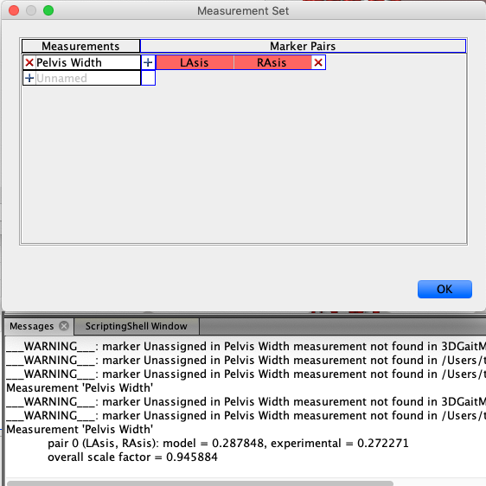In this drop down menu, OpenSim will show you all of the markers that are part of the model. After you select the appropriate marker pair, OpenSim will then obtain the actual distance between these markers from the static .trc file and then display a relative scale factor that compares the model with the experimental data. If you want, you can add another marker pair to the scale measurement by clicking again on the + button. In this case, OpenSim will just take the overall average of all of the marker pairs that are part of the scale measurement. This might be useful if you want to create symmetric scale factors for the left and right legs, for example.

[create some more Measurements that you think you might be useful to scale the entire model (note: you want to select anatomical landmarks, NOT the technical, tracking markers in this step!]

If you are unsure about which markers are anatomical and which are technical, refer to the

*Marker Set Description.pdf* document in the lab folder.

[Select OK after you have created some a Measurement set, which brings you back to the main Scale Factors tab]

[Click on pelvis body name and then in the drop down menu next to the use measurements button, select Pelvis Width]

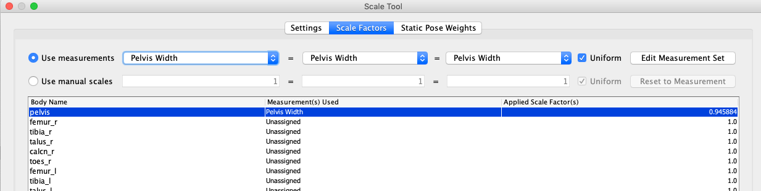

You will now see that the pelvis body will be scaled by Pelvis Width using a scale factor of

0.94. Note that by default, OpenSim chooses uniform scaling, so that this single measurement (Pelvis Width) scales the pelvis in x, y, and z dimensions uniformly. If you want to scale the pelvis differently in other planes, you can uncheck the Uniform box and then select different parameters within each drop down menu (e.g. you might want to scale pelvis depth using markers on the front and back of the pelvis).

You can now set up the scaling for the other body parts using appropriate measurements from the Measurement Set. At this stage, it is probably worth saving all of these measurements and scale factors, in case you want to come back later or use the same scale factors on a different model. You can now go back to this step and Load the same settings, without having to go through this process again.

[select Save… at the bottom of the Scale Tool window and save these settings as ‘SetUpScale.xml’ or something similar]

When scaling the feet bones, it might make sense to scale all of the feet bodies (calcn, talus, toes) using one scale factor (foot length perhaps, using heel to toe markers).

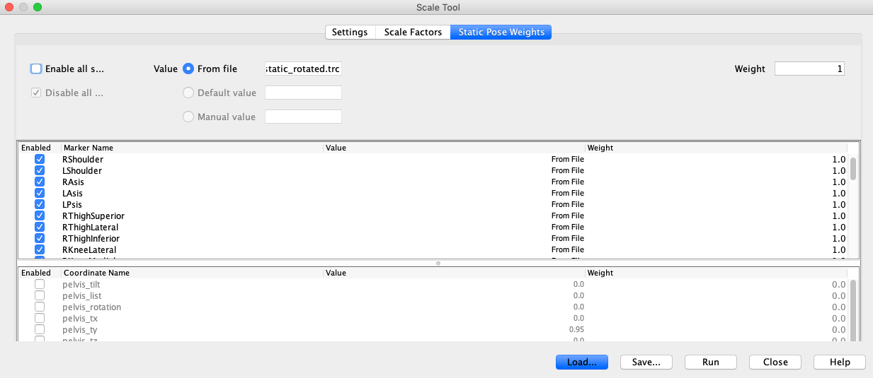Once you have created your scale factors, the last thing to do before clicking Run, is to adjust the Static Pose Weights, which is the third tab on the top of the scale tool. In here you can adjust the weights of the optimization and there are two weightings you can change. The first is a weighting on the markers. In here, you can increase the weights of the anatomical markers (make them 1000 for example) and keep the weights of the tracking markers at 1.0. This will give more weighting to the anatomical markers, which makes sense given we have more confidence in their location.

The second constraint you can impose are on the generalized coordinates. You might want to constrain the model and ensure that the ankle joint or knee joint is in a neutral pose. You have to be careful here, as your participant might have been standing in a weird position, in which case you are not sure if these coordinates should be constrained.

[Now click Run to apply these scaling settings]

After applying these settings, you will see a new model appear next to the generic model. You can right click on the model in the Navigator menu and select Save As to save this scaled.osim model in your folder.

# Task 4. Perform inverse kinematics (IK).

Now that you have a scaled model (the most difficult step!), the next step is to perform inverse kinematics (IK) to track the motion capture trials of interest. First, you will have to go back to Mokka and export your motion capture data as a .trc file.

[drag the *jw_ngait_og1.c3d* file into Mokka and export as a .trc file]

[run the *RotateMarkerData.ipynb* Jupyter notebook to make sure your marker trajectories have the y- axis as vertical]

[go back to OpenSim and select *Tools* > *Inverse Kinematics…* from the main menu] [select the .trc file that you wish to track and provide a name for the output file]

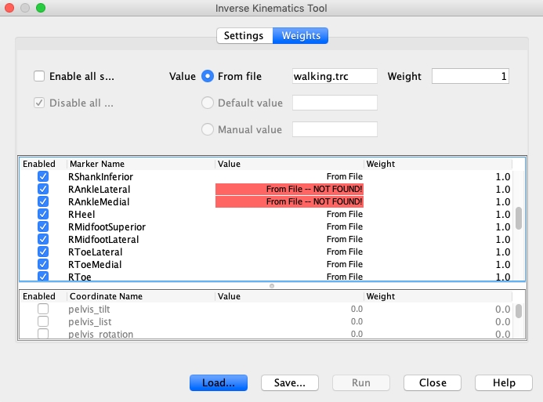At this stage you might notice that the Run button is greyed out. This is because OpenSim is looking for model markers that might not exist in the .trc file. Select the Weights tab at the top of the Inverse Kinematics Tool and you will be able to scroll down the marker list and see the ones that are highlighted in red. These are the anatomical markers that were only present in the standing static trial.

De-select these and you should now be able to run the IK tool. Also note that in the weighting section, you can provide different weighting to the markers you wish to track. Here you might weight markers less if they are prone to soft tissue artefact.

[select *Run* and then *Close* the Inverse Kinematics Tool]

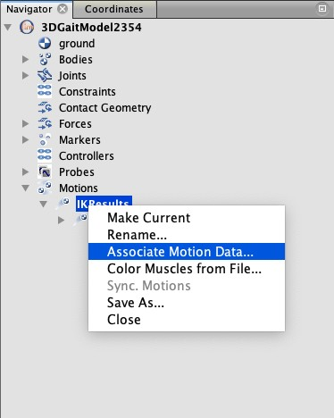You will see the model iteratively move through each frame of data and then provide an IK solution that best-matches the experimental data. The RMS error of the IK solution is printed in the Messages window and you can see which marker has the greatest error. You can also visualise the model vs experimental markers by right clicking on the motion file in the Navigator window and selecting *Associate Marker Data…* You can then select on the .trc file that you just tracked and OpenSim will display the blue experimental markers you were tracking.

This provides you with a subjective assessment of how your IK solution worked. If you have errors > 2cm it could be because the model scaling could be improved.